

Document Type
[Project/Client Name]
Ref. Number: Click to Generate Number


Version: x.x
Date: April 22, 2020

Table of Contents
1 About this Document 4
1.1 Purpose 4
1.2 References 4
1.3 Glossary 4
2 Level 1 5
2.1 Level 2 5

Revisions
Date | Version | Issuer | Remarks
09/06/2020 | 1.0 | Luay Abu Shariha | Initial Version
Approvals
Date | Title | Name | Department | Signature

About this Document

Purpose
This document aims to provide a comprehensive handover of the project for Virgin KSA, ensuring continuity in the management of servers, services, Jira tickets, and analysis of root causes for reported issues. The goal is to ensure a smooth transition and ongoing support.

References
…

Glossary
Item | Description
TKT | Ticket
RCA | Root Cause analysis
SLA | Service Level Agreement
SC | Self Care
DA | Dealer App

Servers and Infrastructre

Server Details (SC)
Server Name | IP Address | Status | Username | Password
Database Server (DB)  VMWSC.Digital DB | 10.4.1.31 | Active | SA | P#ssw-rd098.
SC Application Server 1 | 10.4.1.29 | Active | administrator | P#ssw-rd098
SC Application Server 2 | 10.4.1.23 | Active | administrator | P#ssw-rd098

Server Details (Activation)
Server Name | IP Address | Status | Username | Password | Physical Path
Database Server (DB) | 10.4.95.44 | Active | AppDbAccess | t4v-25QByD
Activation Application Server 1 | 10.125.9.101 | Active | administrator | P#ssw-rd098 | C:\LeadingPoint\CAS.Digital.Prod
Activation Application Server 2 | 10.125.9.102 | Active | administrator | P#ssw-rd098 | C:\LeadingPoint\CAS.Digital.Prod

2.2 Backup and Disaster Recovery
- Backup Strategy: [Details about backup systems in place]
- Disaster Recovery Plan: [Plan summary, key contacts, and recovery time objectives]
- Data Centers: [Information on data center locations and critical information]

API SC :

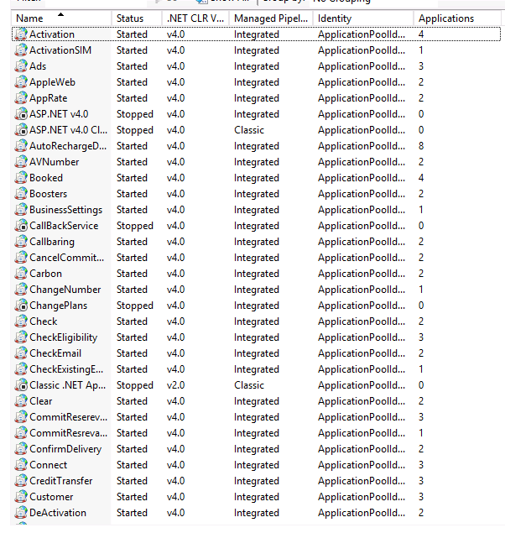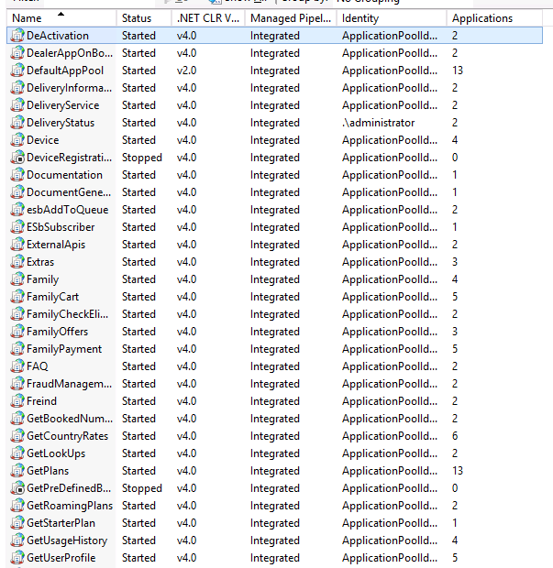
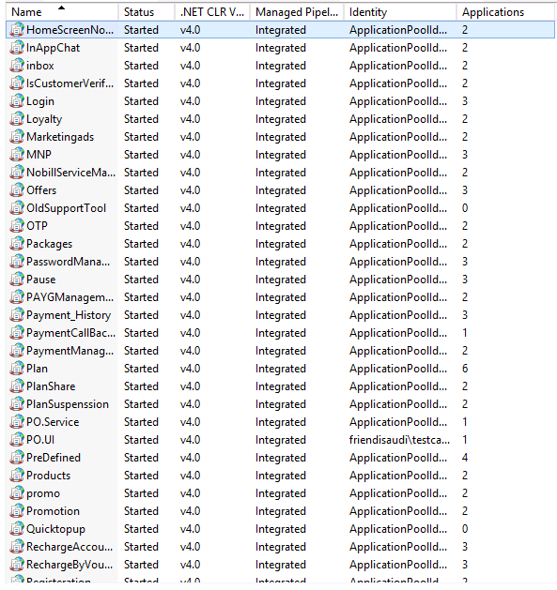

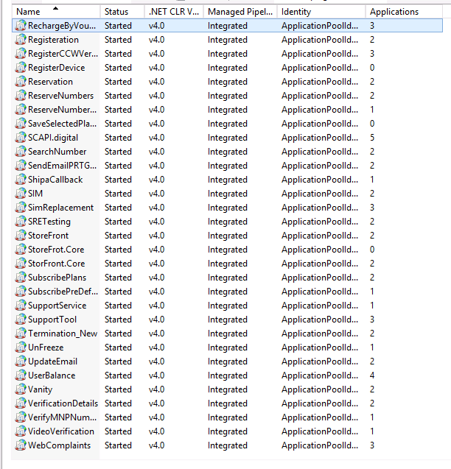

API activation

Services Overview
3.1 Key Services Delivered
Service Name | Description | Status | Owner
[Service1] | [Description] | [Active/Inactive] | [Owner]
[Service2] | [Description] | [Active/Inactive] | [Owner]

3.2 Maintenance and Support
- Support Level: [Details on SLAs and support commitments]
- Service Monitoring: [Tools used, frequency of monitoring, etc.]
- Maintenance Schedule: [Regular maintenance windows and procedures]

Jira Tickets
4.1 Open Tickets

Ticket ID | Description | Priority | Status | Assigned To
[TKT1] | [Description] | [High/Medium/Low] | [Open/In Progress] | [Name]
[TKT2] | [Description] | [High/Medium/Low] | [Open/In Progress] | [Name]

4.2 Closed Tickets
Ticket ID | Description | Resolution Date | Assigned To | Root Cause
[TKT3] | [Description] | [Date] | [Name] | [Root Cause]

Root Cause Analysis and Ticket Analysis
5.1 Root Cause Analysis
For each issue resolved, the following root causes were identified and addressed:
Ticket ID | Root Cause | Resolution | Preventive Actions
[TKT3] | [Root Cause] | [Resolution] | [Preventive Action]

5.2 Ticket Analysis
- Trend Analysis: [Summary of recurring issues and overall trends]
- Time to Resolution: [Analysis of average resolution time for tickets]
- Performance Improvement: [Steps taken to improve service based on ticket analysis]

Documentation and Knowledge Transfer
- User Manuals: [Links or attachments to user manuals and documentation]
- Training: [Details on any training provided or needed]
- Key Contacts:
Name | Role | Email | Phone
John Doe | Project Manager | john.doe@example.com | +1 234 567 8901

Next Steps and Recommendations
- Future Work: [Any upcoming planned tasks or ongoing work]
- Recommendations: [Suggestions for ongoing support, future improvements, etc.]

Sign-Off
This document confirms the successful handover of the project to Virgin KSA, ensuring all necessary details are captured for ongoing support and reference.

